Analysis of Practice
Dimension – Significance
Element - Narration
Narration was a central element in our whole unit due to the drama learning intentions, but it is written into lesson 1 as central focus. This analysis will mention other lessons.
In considering the hook of lesson 1 in ‘The Drama of Cell Life unit’, there are several ways in which the element Narrative addressed the knowledge of core concepts.
- In the first instance the storytelling method of performing a skit was used as diagnostic assessment. The teachers dressed in costume revealed their attributes, without giving away what they are (an animal and a plant cell). They then asked the students to guess their identity.
  - By year 7/8, assumed knowledge would be recognition of a basic cell.
Hook/skit video
https://youtu.be/rKV2oQzxDcs
Annotation for video
  - Moga – I have a nucleus on the side and a thicker membrane that is sturdy, many of us come together to form sunflowers and corn.
  - Jem – I am big and round with a nucleus in the middle, with soft membrane and I can form a big toe or an eyeball.

- The performance of a cell’s attributes and their role in the biological world met the success criteria ‘I can identify how drama expresses scientific ideas.’ These ideas threaded successfully through the units’ pedagogy and other lesson activities.

Feedback

7 out of 8 peers coded Narrative significance as a 5 in lesson 1
‘Drama merged with science which spark student learning interest’ Peer
‘Good way to narrate key concepts’ Peer
‘Year 7/8 love costumes’ Peer
‘Hook persisted through lesson.’ Peer
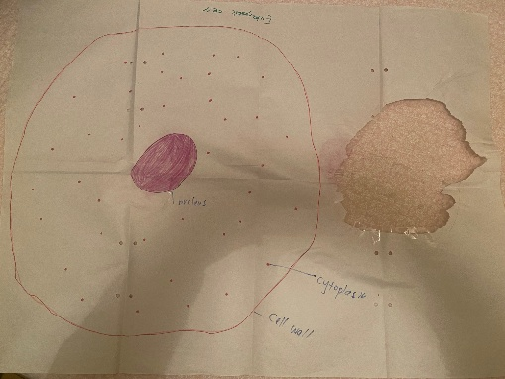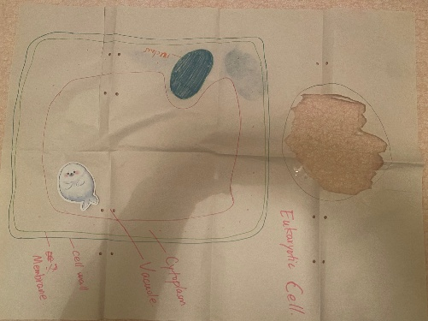
Costumes
- Chinese whispers activity had limited success. This activity came about as an effort to merge Narrative storytelling with the Metalanguage element and introduce learning intention ‘To interpret and communicate scientific meaning through movement and voice’. In theory it connected to both elements and introduced the dramatic space but in practice it created some inertia.
Feedback
‘Chinese whisper game task could’ve been introduced better’ Peer
‘Lot of waiting, not much collaboration, can lower engagement’ Darren
Jem reflection – The integration of science and drama disciplines will be covered in greater detail in the next analysis, Knowledge Integration. But reflecting on it in the light of bringing significance though narrative is also telling. Moga and I went into lesson and unit planning with great openness to each other’s discipline. Where we struggled was, in my opinion, Moga’s focus on detail and content and my focus on plasticity and simplicity.
The content heavy approach was evident in the Lesson 1, 2 and 4 PowerPoint teaching. In lesson 2, I compensated by improvising a ‘what does a cell look like’ response, modelling initially then encouraging others to join in. By doing this I felt like I dislocated from the united leadership Moga, and I had at this time. I struggled to regain direction.
Feedback
‘Explicit teaching part is a little to long and new concepts a little much (since its lesson 1) Maybe design more intuitive activity for teaching time.’ Peer
‘When Moga is answering the ‘unit of cell’ question it not very clear, so the discussion goes to a strange way, but I found out the correct understanding then did my self-regulating.’ Peer
In conclusion, Narration was used successfully to bring to life the science behind cell life. A united presentation of the Narrative element is required if combining disciplines, otherwise pivoting and in class creates fragmentation of teacher leadership.

Analysis of Practice
Dimension – Significance
Element – Knowledge Integration
Element 2 of the Significance dimension, Knowledge Integration, is a focus of lesson 2. An analysis of how effectively this element is used demands ‘identifiable meaningful connections are made between different topics and/or different subjects.’ QTM
In practice most of the lesson 2 centred around a Moga’s quiz, explicit teaching (Unit plan allowance-12 min, on the day 20 minutes) and a conceptual map activity (Unit plan allowance 5 min, on the day10 min). Unfortunately, the connection between drama and science did find a complementary space as there was no time for drama.
- This became a continuation of the disparity mentioned in the analysis of Narrative above. ‘Moga’s focus on detail and content and my focus on plasticity and simplicity’. Moga and I discussed simplifying the PowerPoint slides and amount of content, but this did not translate to the lesson. The quiz and the slides were content heavy which allowed little space for dramatic interplay, spontaneous or planned.
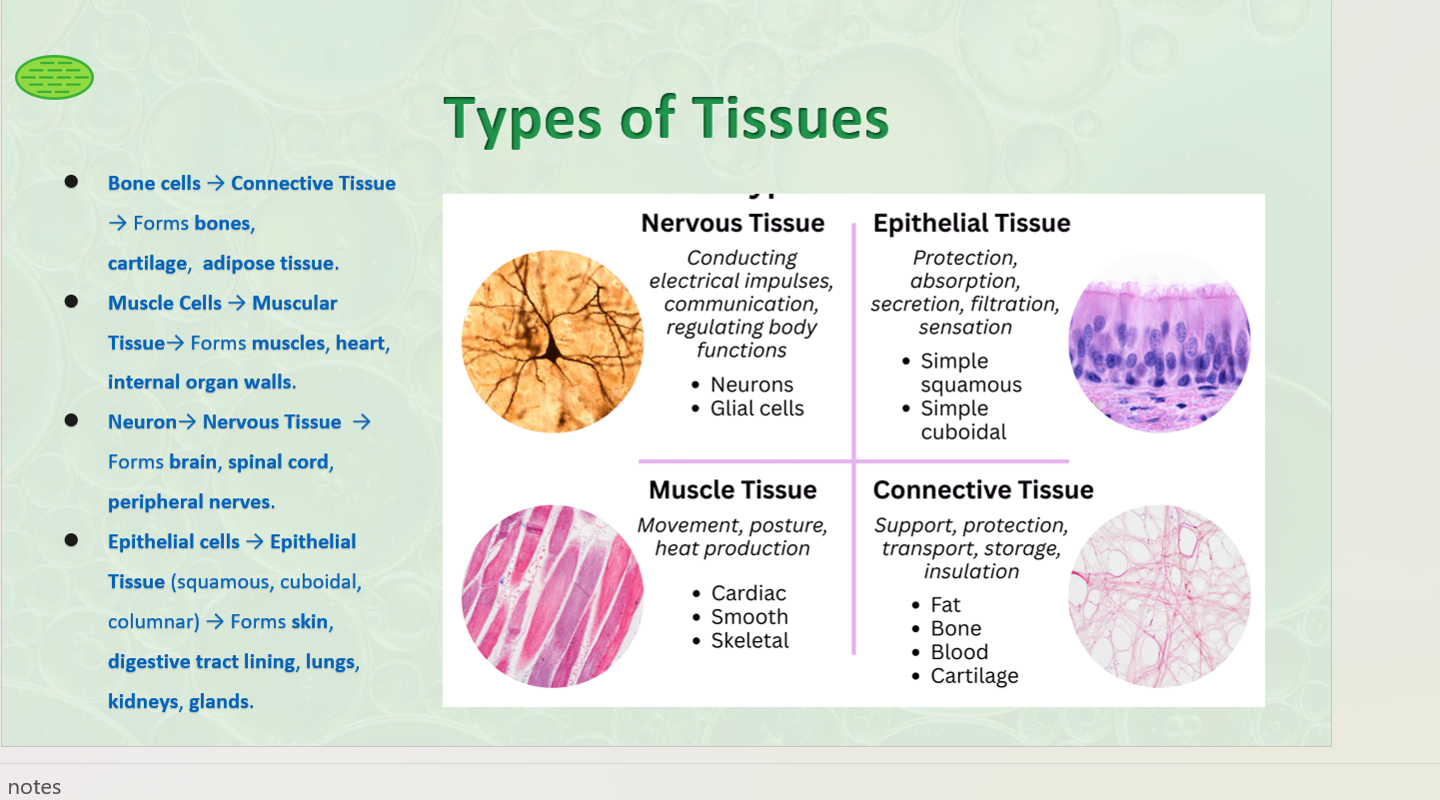
Jem reflection : The class remained engaged till slide 7 at which point the slides became more complex and content heavy.

Feedback

6.7 Peer response coded at 5 for Knowledge Integration in lesson 2.
‘The explanation about drama and science integration is amazing but not enough time to do hands on activities.’ Peer
‘The beginning part of the online quiz a bit difficult, is there any way to simplify that one as well?’ Peer
‘Could more work be done on time management’ Peer
‘Is there a way to make more collaborative rather than speak from the board’ Darre
- To increase the integrated energy I improvised a ‘How does a cell look’ game with the students before the conceptual mapping activity to create some action and play that would allow quick dramatic interpretation opportunity.
  - Pivoting when a lesson does not go to plan is essential, this is a skill that has grown as I’ve taught as a SAT teacher. Something I could not have done without the support of the Positive Behavioural Leaders mentoring, regularly training from my line leader and encouragement from my peer teachers.
Feedback
‘Loved the ‘What does a cell look like’ activity. Fun and engaging.
‘Drama and science perfect integration between each other. The activity didn’t get run as ran out of time but the drama combining with science very good and I was excited to do.

Jem reflection
Science is at its core content driven and conceptual; Drama is at its core abstract and loosely structured. For this unit the success criteria centred around identifying and describing basic plant and animal cell structure and using drama and performance to interpret, process and recall this learning. To do this…
  - The science discipline needed to rely on the pedagogy of drama to be a vehicle of learning.
  - The drama discipline depended on science to simplify content and hold loosely to an expectation students would learn detailed facts of said pedagogy.
Despite the incongruence discussed in no 1 of Knowledge Integration analysis, Moga and I were able to ‘contribute to a deeper understanding of core concepts’ as required in the QTM.
- By lesson 3 Moga and I reached a more productive rhythm integrating our disciplines as evidenced in Moga’s riddle activity, Jem’s story and sorting activity and the group performances of a cell hierarchy. Lesson 3 was a narrative and knowledge Integration rich space imbedded in key collaborative elements Social Support (discussed in next analysis) and Inclusivity.
Riddle Activity
https://youtu.be/C7AO7iurkAM
Sorting Activity
https://youtu.be/PRZYUT-PNRA
Performance Activity
https://youtu.be/iSvnD1X2ays
Feedback (lesson 3)
‘Drama and science integration cool, very engaging for students, good way to retain knowledge…ask the students in 2 months’ time they will remember the content because of the role play, powerful and fun’. Darren

