Analysis of Practice
Dimension – Intellectual Quality
Element – Higher Order Thinking
The final lesson of ‘The Drama of Cell Life’ successfully explored the element Higher Order Thinking.
This element is demonstrated by students though the synthesis, generalization, explaining of, and hypothesizing’ of learning to arrive at ‘conclusions and interpretations’ QTM. Moga and I were excited to put together an activity that gave students online the opportunity to choose, research, and compilate answers for a specific topic and potentially ‘generate unexpected concepts, ideas, products and take learning in a new direction.’ QTM
- Illness Research Task
This task was created to address the requirements of higher order thinking. Moga created guiding questions that modelled for students how to research and respond.
Video from website of task
https://www.youtube.com/watch?v=Yp2VSVhSCvM
Task sheet for activity – Drama of Cell Life Website
https://renmy018.wixsite.com/the-drama-of-cell-li
See tab on website, for full task sheet
Feedback
‘Guiding questions helps students develop higher order thinking skills by offering hint or clue.’
‘Illness activity requires us to apply and recognize knowledge rather than repeat definitions.’
‘Illness used higher order thinking because it asked me to explain causes, processes and impacts instead of listing just facts, I had to make real world connections and think deeply about illnesses.’
Some examples of student responses
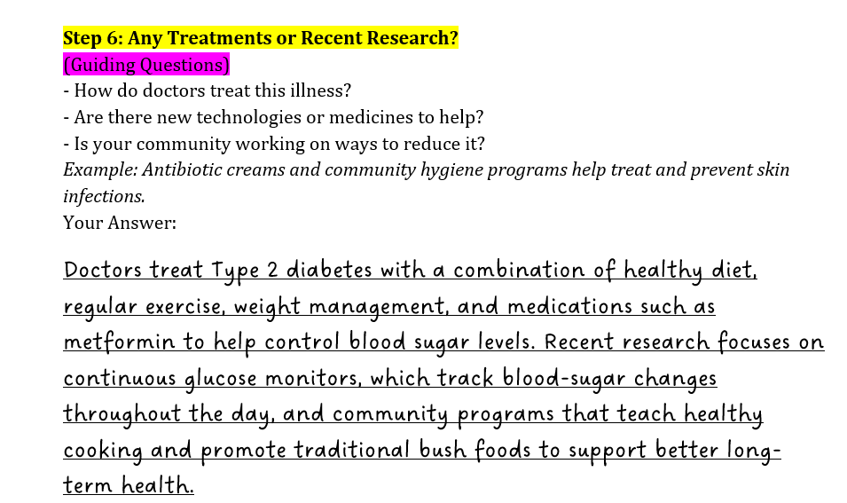
Jem Feedback
The response from students challenged students to synthesize, generalize and explain their research on an illness. To develop this element the activity could have pushed for problem solving skills, for example in a scenario where they had to trouble shoot a cells destabilization leading to illness. Which cellular system is affected, how are the cells radicalizing. However, the time allowed for the lesson and the age of the students may make this expectation to high.

Analysis of Practice
Dimension – Intellectual Quality
Element – Cultural Knowledge
Cultural knowledge rounded out the elements for the unit plan Moga and I created. It celebrated the diversity of our experience in this subject. Working with two disciplines, Science and Drama brought together 2 distinct education cultures and our class integrated mature aged students, international students, and a variety of different disciplines.
When Cultural knowledge is embedded, the result is practice and classrooms that embrace and embody ‘traditions, beliefs, skills, knowledges, languages, practices and practices of diverse social groups authentically’. QTM
- Lesson 4 Illness Research Task was built around cultural exploration and Moga set the tone with an excellent introduction to First Nation Australians health experience set against the impact of European colonisation.
YouTube video of lesson 4 Task 1
View from 50 sec to 2 min to hear Moga’s introduction.
https://www.youtube.com/watch?v=Yp2VSVhSCvM
Feedback
Cultural knowledge was recognised and valued in the lesson because the teacher began by using an example about skin infections in an Aboriginal community in South Australia. This showed respect for Indigenous knowledge and experiences, helping us understand how culture and community influence health. The task also encouraged students to choose an illness connected to their own culture, family, or community, which made the activity more inclusive and personal. By doing this, the lesson challenged the usual focus on Western or mainstream health examples and recognised the importance of learning from diverse cultural perspectives.

- Lesson 4 set out to extend the learning intention ‘To recall living things and describe basic structures and functions of cells in plants and animals.’ By researching the effect of disease on multicellular organisms and the cultures they can sometimes overshadow, an opportunity arises to give students an insight not only into radicalized cell science but also how ‘different social groupings are identified in relation to dominant…culture.’
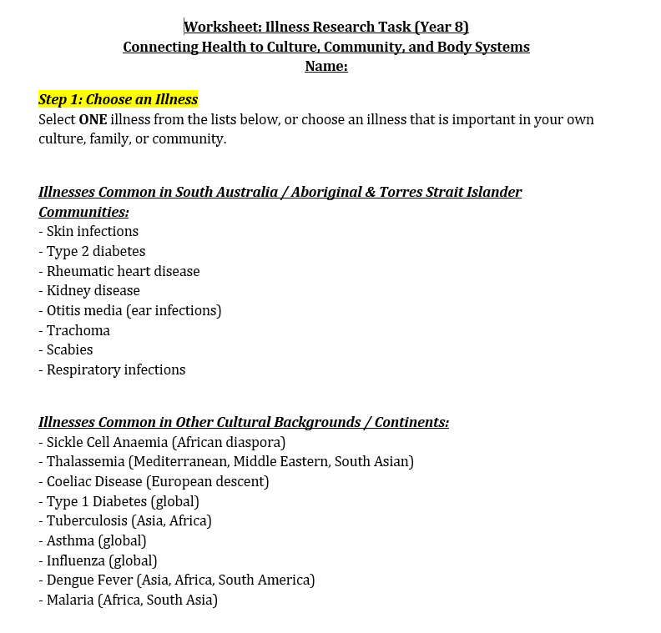
Example of student research on worksheet
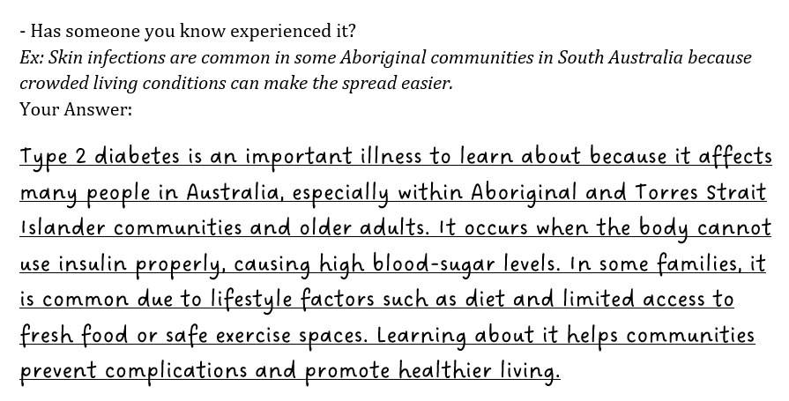
This research demonstrates the student recognizes how an illness affects Australia’s First Nation community as well as some basic scientific facts on Type 2 Diabetes disease.

