Analysis of Practice
Dimension – Quality Learning Environment
Element – High Expectations
High Expectations Is part of Dimension 2, Quality Learning Environment. A strong indicator according to the QTM that expectations are high is ‘not how many students are participating, but how many are participating in challenging work.’
- In the explicit teaching section of lesson 2 Moga included content designed to motivate students to ‘master challenging work.’ QTM
  - Using the pedagogical method of Socratic questioning Moga was able to encourage students to take risks as they extended their learning from basic cell structure to more complex multicellular organisms.
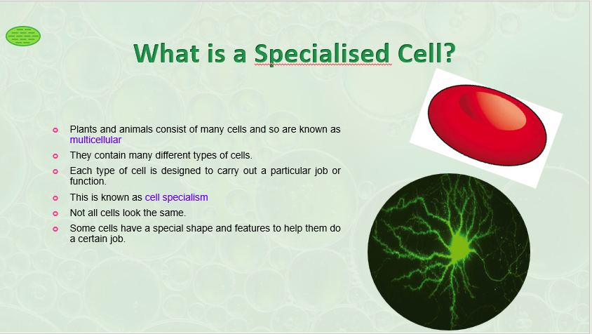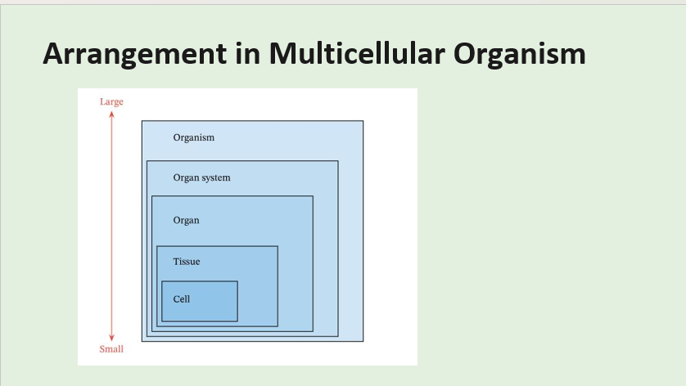
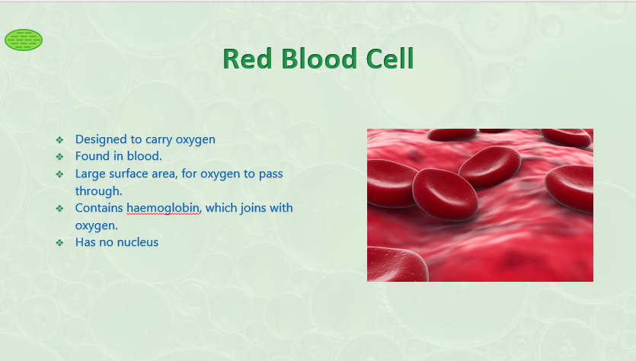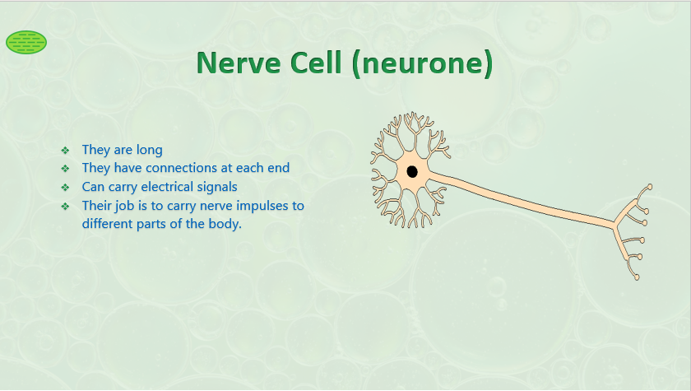
Socratic Questions and responses for the Red Blood Cell slide
Moga - Why are red blood cells shaped this way.
Student - Flow through the veins more easily
Student - So, they don’t hurt the tissues and other things
Moga - Nice thinking, you are already starting to think like a scientist.
https://youtu.be/ORtZuu0Bh1M
Video of Moga teaching section above

- The previous lesson provided prior knowledge about the basic of cells, therefore fostering high expectations around the complexity of different types of cells was reasonable. The first examples worked well. However, the lesson content became too complex that led to a fall in confidence.
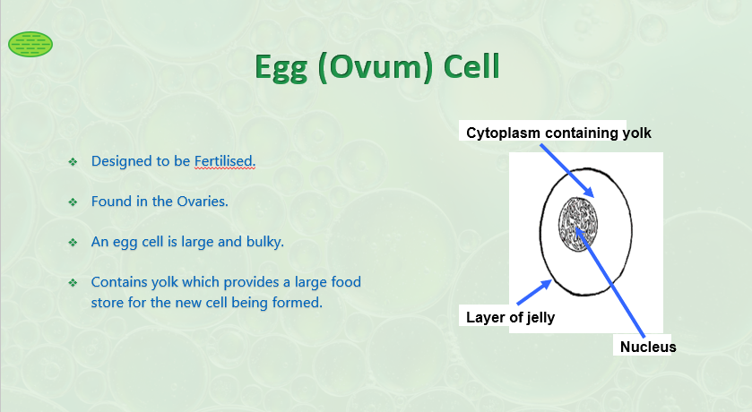
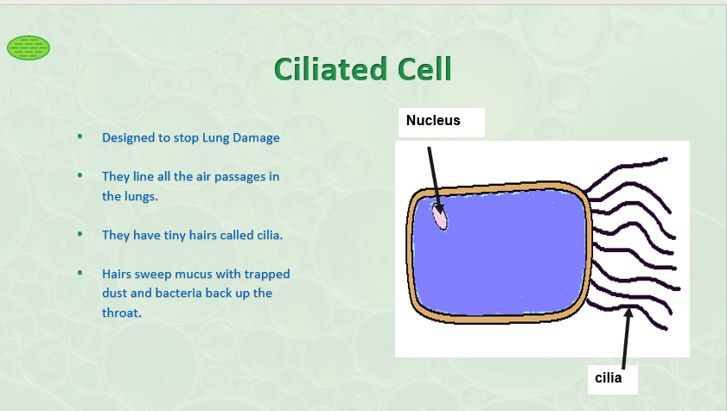
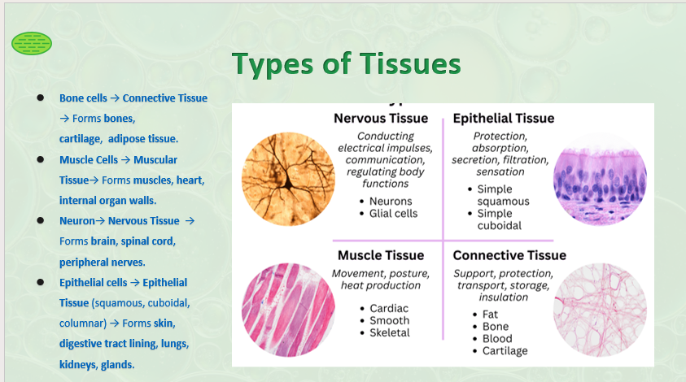
The slides from this point on became increasing complex
Feedback
Maybe too deep for year 7. Peer
Maybe too high, the concept and terms about organelle and organ systems are not stated clearly enough. Peer
Consider layout of slides, too much small writing, can lose the impact and focus of students > becomes unclear. Darren
- Despite this, the conceptual map activity, which required a working knowledge of the lesson content, suited some learners who enjoyed the challenge.

Feedback (See pictures below)
Pair work needs to take risks, searching and reporting on one system/cell. Peer
Jem Feedback
I think this is the challenge of high expectations, the diverse learning capacity of a group of students makes it hard to differentiate challenging work for everyone. The QTM suggests the teacher identify prior learning and monitor growth continually for all students. This comes with experience and positive classroom relationships. Moga would have benefited from pivoting in her lesson when the signs of disengagement showed.
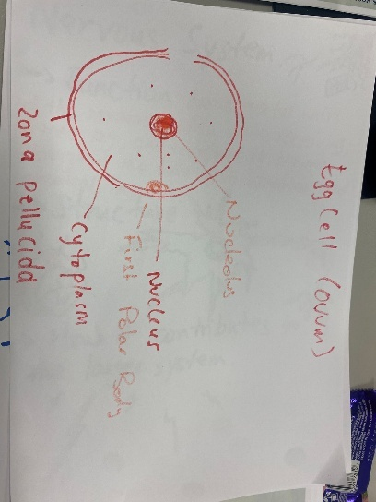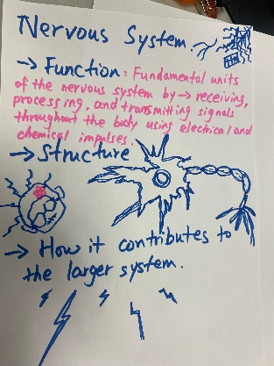
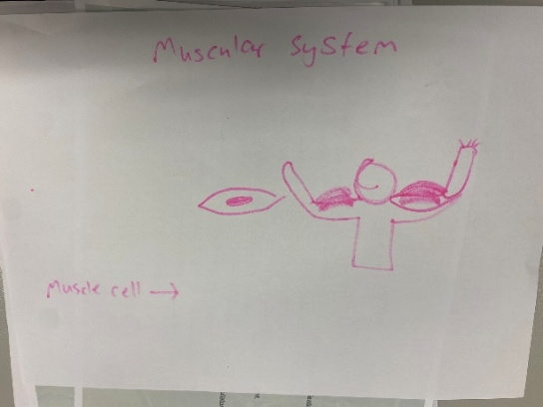
Conceptual Map Activity – Students were given a system to research and encouraged to attempt to draw the cellular hierarchy in conceptual map.

3.3 Peer response coded at 5 for High Expectations in lesson 2.
Analysis of Practice
Dimension – Quality Learning Environment
Element – Social Support
Social Support, like inclusivity and substantive communication, set out to ensure the student exists in a safe space where they are heard and valued. The application of Social Support in the classroom is broad, centring around words like encouragement, solidarity, and positive environment.
- Built into the Drama intentions are core values that guide my practise.
  - In drama you will fail and feel exposed, learn to fail well and it will cultivate resilience.
  - Everyone can have ago; mutual respect and encouragement is nonnegotiable.
  - Performing is a highly transferrable skill, developing an essential skill for life, innovative thinking.
- Moga set the scene with the introductory ‘riddle’
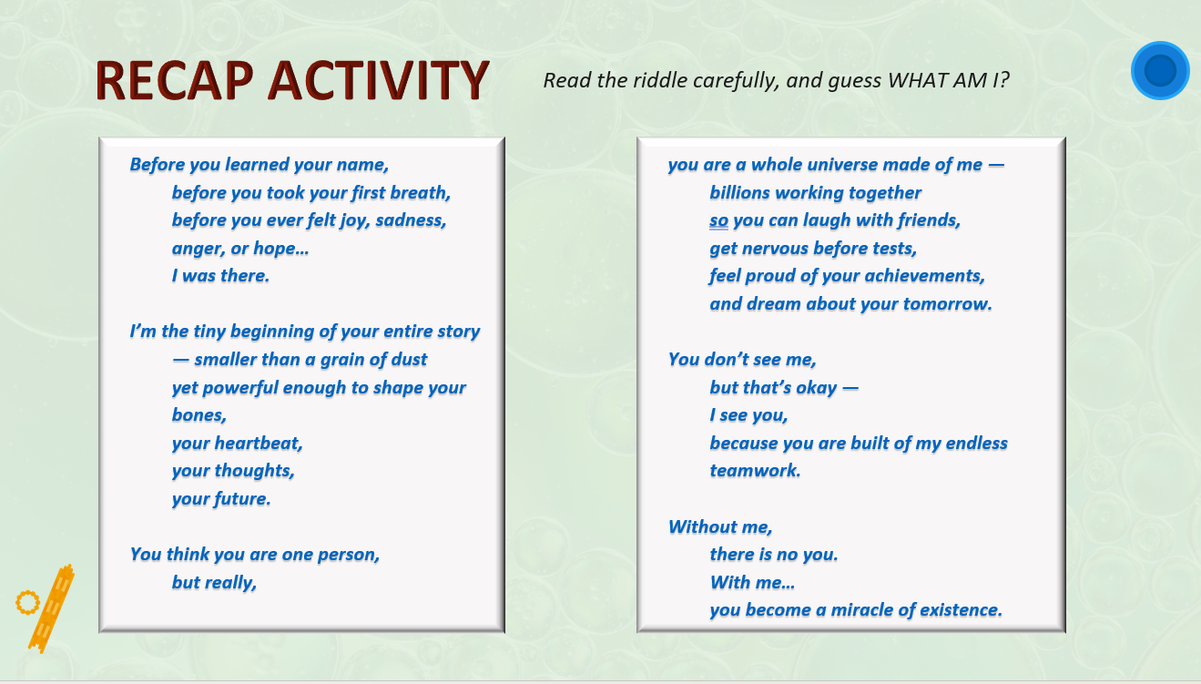
This introduction set the tone by the teacher of the student’s intrinsic value as a human and was an excellent foundation for Social Support. Each activity that followed required a safe and supportive learning space.
Video of Riddle activity.
Feedback
All the group activities like grouping, stickers (sorting) and acting, require social support from the others. Peer
- The riddle, sorting and performance video all show consistent evidence of encouraging and positive statements. https://youtu.be/C7AO7iurkAM
‘It is ok if you get it wrong, just have a go’
‘Go sit down, thank you so much for having a go’
Clear and dispassionate directions
‘Gentlemen can I get you to focus back on task’
‘Great collaboration, please return to your seat with your groups.’
- Sorting Activity
https://youtu.be/PRZYUT-PNRA
Social Support is cultivated by group and team activities that are collaborative and democratic.
Jem Feedback
At the end of this activity, one student exclaimed an apology for making a mistake within the group. As a teacher I think its important to teach students to monitor their apologies, students do not need to apologise for making learning mistakes. Being in a group and not being perfect is normal, not a mistake.
- Performance activity.
Celebrating community and success creates a climate of mutual respect between students and teachers, and students and students.
The cumulative activity of creating an improvisation of a cell system was successful as a collaborative activity experienced and achievable by all students. As students saw the teachers model the skit they were to create and perform, they felt some solidarity with the teachers, then with each other as they faced performing up the front with each other.

Feedback
Good role play. Not only for students but also for students but also for teachers. Teachers and students together to play the different role. Teachers’ behaviour good affect the students learning.
Jem Feedback.
The Drama of Cell Life unit plan was designed with a culmination of the science and drama learning intentions in week 3, as a partnership Moga and I were becoming functioning halves and this allowed us to prioritise a supportive space in the classroom. Activities like the Sorting Activity and the Performance served as formative assessments for the students, showing us how independently they could recall the learning. This laid the path for week 4 which focused on seeing how the students went with some higher order thinking applications of their learning.
Performance Activity
https://youtu.be/iSvnD1X2ays
Feedback
Very engaging for students, a good way to retain knowledge, powerful…Ask the students in 2 months’ time, they will remember because of the role play. Darren.

5 out of 7 peers coded Social Support as a 5 in lesson 3

